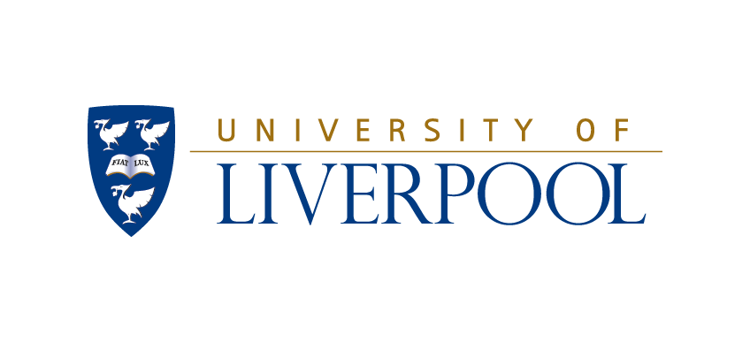

The University of Liverpool is a research-led government-funded university in the north of England. It currently has about 20,000 students studying for Bachelors (e.g. BEng), masters level (e.g. MEng and MSc) and doctoral level (PhD) degrees. About 1000 of these students are studying for degrees in engineering. The following programmes are offered in the full CDIO context (contact name in brackets):
Aerospace Engineering BEng and MEng (Prof Ken Badcock) k.j.badcock@liv.ac.uk
Civil Engineering BEng and MEng (Dr Linda Mountain, Dr Marios Soutsos) l.mountain@liv.ac.uk; m.n.soutsos@liv.ac.uk
Mechanical Engineering BEng and MEng (Dr Graham Schleyer) schleyer@liv.ac.uk
Materials Engineering BEng and MEng (Dr Tim Bullough) timbull@liv.ac.uk
(General) Engineering BEng and MEng (Dr Geoff Dearden) g.dearden@liv.ac.uk

Seven Masters (MSc) programmes are also offered with many of the CDIO attributes.
Advanced Engineering Materials (Dr Yuyuan Zhao) y.y.zhao@liv.ac.uk
Advanced Manufacturing Systems & technology (Prof Bernard Hon) honkk@liv.ac.uk
Engineering Applications of Lasers (Prof Ken Watkins) k.watkins@liv.ac.uk
Maritime civil Engineering (Prof Daoyi Chen) Daoyi.chen@liv.ac.uk
Aerospace & Mechanical Systems Engineering (Dr Jan Blachut) em20@liv.ac.uk
Product design & Management (Prof Bernard Hon) honkk@liv.ac.uk
Simulation in Aerospace Engineering (Dr George Barakos) g.barakos@liv.ac.uk

PhD supervision is offered across the Department's eight research groups, viz Flight Science, Structural and Functional Materials, Hydraulics and Fluids, Dynamics and Control, Manufacturing, Construction (Civil) engineering, Laser engineering.

All these programmes are offered within the School of Engineering [see www.liv.ac.uk/engdept/] and the primary CDIO contacts are:
Dr Bob Mines (Chair of the Board of Studies) r.mines@liv.ac.uk
Professor Peter Goodhew (Director of Learning and Teaching) goodhew@liv.ac.uk
Professor Gareth Padfield (Head of School) gareth.padfield@liv.ac.uk

