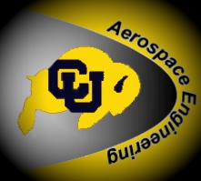


REGISTRATION

AEROSPACE ENGINEERING INDUSTRY SYMPOSIUM
April 20, 2012, 8:00 am – 4:00 pm
University of Colorado at Boulder
Department of Aerospace Engineering Sciences
Boulder, CO 80309-0429

First name: | Last name:
Affiliation:

Address 1: | Address 2:
City / town: | Country: USA
State / province: | Zip / postal code:
Email: | Telephone:

Please register by April 15 if possible. A buffet lunch will be offered to all guests.

RSVP or Mail Registration to
Lynne Salinkas: lynne.salinkas@colorado.edu, (303) 735-0855

The event will be held in the Discovery Learning Center (DLC) on the Boulder campus of the University of Colorado at Boulder. Parking is available in Lot 436, across Regent Drive. Parking Permits are $7.75 per day and can be purchased from Police & Parking Services, located in the building on the east sidewalk near the garage, SE section of Lot 436, Regent Dr. (See http://www.colorado.edu/campusmap/ )

Registration tables will be set up at 8:00 a.m. inside the Discovery Learning Center to collect last minute registrations.

Directions to campus: http://www.colorado.edu/visit/directions/index.html

Questions? Contact: → patti.gassaway@colorado.edu, claire.yang@colorado.edu

